|  |  |
| --- | --- |
| Ex.No.4  **14.09.2022** | **Insertion Sort** |

|  |
| --- |
| **AIM:** |

To write and execute Java program to perform Insertion Sort.

|  |
| --- |
| **Pseudocode:** |

1. Initialize n = Length of Array
2. InsertionSort(Array, n)
3. {
4. for i = 1 to n-1
5. {
6. value = Array[i]
7. position = i
8. while (position > 0 and Array[position-1] > value)
9. {
   1. Array[position] = Array[position - 1]
   2. position = position - 1
10. }
11. Array[position] = value;
12. }
13. }

|  |
| --- |
| **Explanation:** |

1 In first cycle, get 2nd element and order it according to 1st element. i.e, if smaller place it before 1st element.

2 In second cycle, get 3rd element and order it according to 1st and 2nd element. i.e, place them in ascending order.

3 Now do the same in all subsequent cycles.

4 Perform such (number of elements – 1) cycles.

You will get sorted list.

|  |
| --- |
| **Example:** |

Firstly we will pick up list of 5 numbers: 22, 21, 25, 24, 23. Now we sort the array starting from second element i.e. 21.

Now it will compare it with the element before it, and swap if the second element is smaller i.e. 21,22,25,24,23.

Now it will take 3rd element and compare it with its previous one and swaps if it smaller i.e. 21,22,25,24,23.

This step recurse till the array is sorted.

21,22,24,25,23.

21,22,24,25,33.

21,22,24,23,25.

21,22,23,24,25.

And at last you print the sorted array:

21,22,23,24,25.

|  |
| --- |
| **Program Code:** |

import java.util.*;

class InsertionSort {

    public static void main(String[] args) {

        try {

            Scanner input = new Scanner(System.in);

            System.out.println("Enter the size of an Array");

            int size = input.nextInt();

            if(size<=0){

                System.out.println("Please enter a number greater than 0");

                System.exit(0);

            }

            int[] arr = new int[size];

            System.out.println("Enter the Elements of an Array");

            for (int i = 0; i < size; i++) {

                arr[i] = input.nextInt();

            }

            for(int i=1; i<arr.length;i++){

                int temp=arr[i];

                int j=i-1;

                while(j>=0 && temp < arr[j]){

                    //swap

                    arr[j+1]=arr[j];

                    j--;

                }

                arr[j+1]=temp;

            }

            for(int i=0;i<arr.length;i++) {

                System.out.print(arr[i] + " ");

            }

            System.out.println();

            input.close();

        } catch (InputMismatchException e) {

            System.out.println("Please enter a valid integer!!!");

        }

    }

    }

|  |
| --- |
| **Output Screenshots:** |

* **CORRECT OUTPUT**

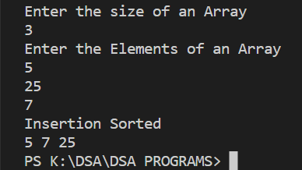

* **WRONG OUTPUT**

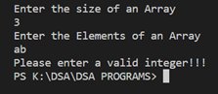

|  |
| --- |
| **RESULT:** |

Thus, the programs for the given problem statements has been executed and the results are verified successfully.